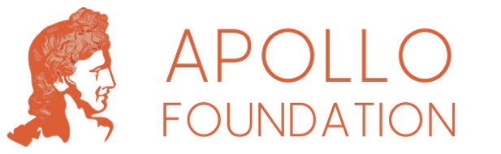
Application to
Apollo Foundation
Main Grants Programme

1 About your Charity

Organisation Name

Registered Name (if different)

Registered Charity Number

Website

Please introduce us to your organisation – your mission and main activities

(up to 150 words)

In which geographic region do your beneficiaries/service users live?

What was your total income in your last audited accounts?

What was your total expenditure in your last audited accounts?

How much does your organisation have in free reserves, as per your last audited accounts?

This should be your total Unrestricted funds minus any Fixed Assets

What is the amount required to meet your reserves policy?

2 About your Project

Project Title

Project Summary

(up to 50 words)

Tell us about the work you would like us to fund.

We are especially interested in supporting projects, activities or interventions that have been proven to work, helping them continue to improve the quality of life and future prospects of those they seek to help.

In the first section, please tell us about the need your project, activity or intervention is designed to address, and the impact it has had so far.

In the second section, please tell us about your future plans, the specific activity you would like the Apollo Foundation to support and the difference a grant from us will make.

In this section, please tell us about your work – the need it addresses, the work you have done to date and how your work has proven to be successful

(up to 500 words)

In this section, please tell us about your future plans for this work and the difference a grant from the Apollo Foundation would make.

We are particularly interested in learning how our grant will enable you to improve the sustainability of your work, and/or how it will enable you to scale up your work to achieve greater impact

(up to 500 words)

What is the total cost of the work?

Please tell us how much has been raised to date (and from where) and your plans for covering any remaining shortfall

(up to 75 words)

How much are you requesting from the Apollo Foundation?

